**Ideation Phase**

**Define the Problem Statements**

|  |  |
| --- | --- |
| Date | 29 June 2025 |
| Team ID | LTVIP2025TMID20850 |
| Project Name | Smart Sorting Transfer Learning for identifying rotten fruits and vegetables |
| Maximum Marks | 2 Marks |

**Customer Problem Statement :**

Consumers, vendors, and retailers often face challenges in identifying **rotten or spoiled fruits and vegetables** by visual inspection alone. This can lead to:

* **Health risks** from unknowingly consuming spoiled produce
* **Increased food waste** due to uncertainty in quality
* **Reduced customer trust** in grocery vendors and marketplaces
* **Time-consuming manual sorting** processes in supply chains

Example:

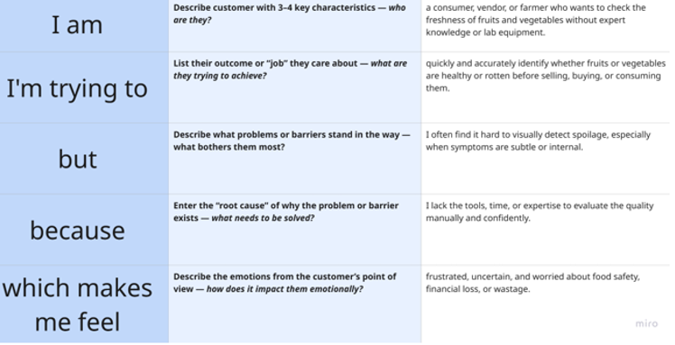

Reference: <https://miro.com/templates/customer-problem-statement/>

**Example:**

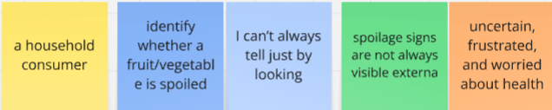

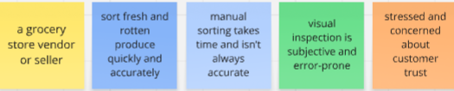

Some of th problem statements are listed below

|  |  |  |  |  |  |
| --- | --- | --- | --- | --- | --- |
| **Problem Statement (PS)** | **I am (Customer)** | **I’m trying to** | **But** | **Because** | **Which makes me feel** |
| PS-1 | a household consumer | identify whether a fruit/vegetable is spoiled | |  | | --- | | fruit/vegetable is spoiled |  |  | | --- | | I can’t always tell just by looking | | |  | | --- | | just by looking |  |  | | --- | | spoilage signs are not always visible externally | | uncertain, frustrated, and worried about health |
| PS-2 | a grocery store vendor or seller | sort fresh and rotten produce quickly and accurately | manual sorting takes time and isn’t always accurate | visual inspection is subjective and error-prone | stressed and concerned about customer trust |